CSE 107: Lab 01: Simple Image Manipulations in Python.
Vedant Sinha
LAB: Thursday 10:30am-1:20pm

September 27, 2025

Task 1: Computing the maximum value of an image. Rotating an image.

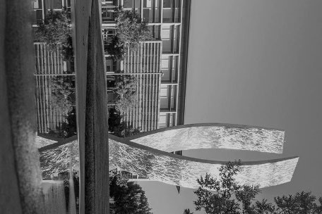

Figure 1: The grayscale Beginnings image rotated 90 degrees clockwise.

Answers for Task 1:
1) Max grayscale Beginnings value: 211
2) Max clockwise-rotated grayscale value: 211
3) Yes. Rotation reorders pixels but doesn’t change pixel intensities, so extrema are preserved.
4) Most difficult: implementing correct index mappings for 90° rotations and ensuring shapes swap without hardcoding; also avoiding built-ins while keeping loops correct and efficient.

Task 2: Writing a function that computes the inverse of a grayscale image.

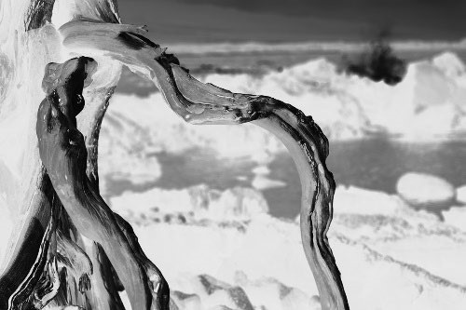

Figure 2: The inverse of the Tree image.

Answers for Task 2:
1) Maximum pixel value of inverse image: 236
2) It equals 255 − min(original), inversion maps low originals to high inverses.
3) Most difficult: ensuring the inverse math and loop indices are correct while avoiding built ins.

Task 3: Creating a gradient grayscale image. Computing the image average.

Figure 3: The gradient image.

<Your answers to the task questions>
1) Average pixel value: 127.5
2) Expected because values are uniformly 0..255 in each row, so the mean is (0+255)/2.
3) Most difficult: ensuring the gradient fills correctly using loops and maintaining dtype as uint8 when saving.

Task1.py
# Import pillow from PIL import Image, ImageOps
# Import numpy import numpy as np from numpy import asarray
# Read the image from file. im = Image.open('Beginnings.jpg')
# Show the image. im.show()
# Convert image to gray scale. im_gray = ImageOps.grayscale(im)
# Show the grayscale image. im_gray.show()
<the rest of your code>

pixel_matrix = im_array

# Compute maximum pixel value using nested loops (no built-ins for max)
rows, cols = pixel_matrix.shape
max_val = 0
for r in range(rows):
for c in range(cols):
val = int(pixel_matrix[r][c])
if r == 0 and c == 0:
max_val = val
elif val > max_val:
max_val = val

print("Max of grayscale Beginnings image:", max_val)

# Rotate 90 degrees counterclockwise using nested loops
rot_ccw = np.zeros((cols, rows), dtype=pixel_matrix.dtype)
for r in range(rows):
for c in range(cols):
# Mapping for 90 CCW: (r, c) -> (cols - 1 - c, r)
rot_ccw[cols - 1 - c][r] = pixel_matrix[r][c]

# Create image from CCW rotated matrix and display+save
im_ccw = Image.fromarray(rot_ccw)
im_ccw.show()
im_ccw.save('Beginnings_gray_rotated_ccw.jpg')

# Rotate 90 degrees clockwise using nested loops
rot_cw = np.zeros((cols, rows), dtype=pixel_matrix.dtype)
for r in range(rows):
for c in range(cols):
# Mapping for 90 CW: (r, c) -> (c, rows - 1 - r)
rot_cw[c][rows - 1 - r] = pixel_matrix[r][c]

# Create image from CW rotated matrix and display+save
im_cw = Image.fromarray(rot_cw)
im_cw.show()
im_cw.save('Beginnings_gray_rotated_cw.jpg')

# Compute maximum pixel value of the clockwise rotated image using nested loops
rows_cw, cols_cw = rot_cw.shape
max_val_cw = 0
for r in range(rows_cw):
for c in range(cols_cw):
val = int(rot_cw[r][c])
if r == 0 and c == 0:
max_val_cw = val
elif val > max_val_cw:
max_val_cw = val

print("Max of clockwise rotated grayscale image:", max_val_cw)

Task2.py
# Import pillow from PIL import Image, ImageOps
# Import numpy import numpy as np from numpy import asarray
# Read the image from file. im = Image.open('Tree.tif')
# Show the image.
im.show()
# Print the image mode. print("image mode is:", im.mode)
# Create numpy matrix to access the pixel values. im_pixels = asarray(im)
# Import myImageInverse from myImageInverse from MyImageFunctions import myImageInverse im_inv_pixels = myImageInverse(im_pixels)
# Create an image from im_inv_pixels. im_inv = Image.fromarray(np.uint8(im_inv_pixels))
# Show the inverse image. im_inv.show()
# Save the inverse image to a file. im_inv.save("Tree_inv.tif")
<the rest of your code>

# Compute maximum pixel value of the inverse image using nested loops (no built-ins)
rows_i, cols_i = im_inv_pixels.shape
max_inv = 0
for r in range(rows_i):
for c in range(cols_i):
val = int(im_inv_pixels[r][c])
if r == 0 and c == 0:
max_inv = val
elif val > max_inv:
max_inv = val
print("Max of inverse Tree image:", max_inv)

# Also compute the minimum of the original image using nested loops (for relationship)
rows_o, cols_o = im_pixels.shape
min_orig = 0
for r in range(rows_o):
for c in range(cols_o):
val = int(im_pixels[r][c])
if r == 0 and c == 0:
min_orig = val
elif val < min_orig:
min_orig = val
print("Min of original Tree image:", min_orig)
print("255 - min(original) =", 255 - min_orig)

MyImageFunctions.py
# MyImageFunctions.py
# Import pillow from PIL import Image, ImageOps
# Import numpy import numpy as np from numpy import asarray
def myImageInverse( inImage_pixels ):
# This function takes as input a numpy matrix representing a grayscale image and # outputs another numpy matrix which is the image inverse of the input.
# That is, for each pixel, output_value = 255 - input_value
# # Syntax:
# out_numpy_matrix = myImageInverse( in_numpy_matrix )
# # Input:
# in_numpy_matrix = the grayscale values of the input image
# # Output:
# out_numpy_matrix = the grayscale of the inverse image
# # History:
# S. Newsam 9/12/25 Created
# S. Newsam 9/13/25 Modified to use numpy instead of PIL image
<the rest of your code>
rows, cols = inImage.shape
# Create output matrix of same size and dtype
outImage = np.zeros((rows, cols), dtype=inImage.dtype)
# Compute inverse using nested loops
for r in range(rows):
for c in range(cols):
in_val = int(inImage[r][c])
out_val = 255 - in_val
outImage[r][c] = out_val
return outImage

Task3.py
# Import pillow from PIL import Image, ImageOps
# Import numpy import numpy as np from numpy import asarray
# The size of the gradient image.
rows = 100 cols = 256
# Create a numpy matrix of this size. im_pixels = np.zeros(shape=(rows, cols))
<the rest of your code>

for r in range(rows):
for c in range(cols):
im_pixels[r][c] = c

# Create image from numpy matrix (ensure uint8 type)
im_grad = Image.fromarray(np.uint8(im_pixels))

# Display the image
im_grad.show()

# Save the image as .tif
im_grad.save('Gradient.tif')

# Compute the average pixel value using nested loops (no built-ins)
total = 0
count = 0
for r in range(rows):
for c in range(cols):
total += int(im_pixels[r][c])
count += 1

avg = total / count if count > 0 else 0
print("Average pixel value of gradient image:", avg)

